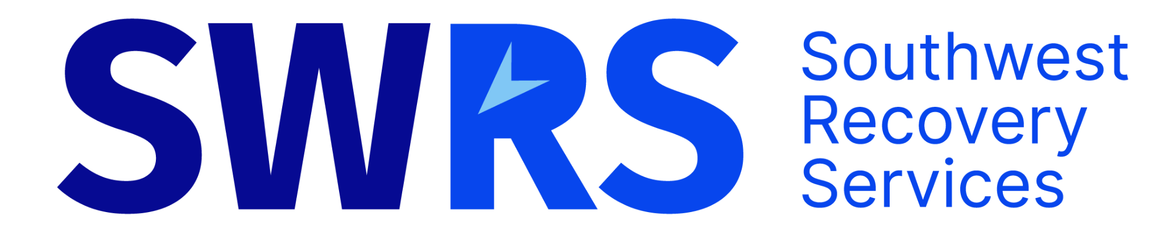

Welcome to FRSTeam
Your A/R Support Guide with SWRS
This short guide explains how FRSTeam supports your office’s accounts receivable (A/R) and how SW Recovery Services (SWRS) helps when payments stall. You are not expected to be an A/R expert — this system exists to protect your time and cash flow.

What This Is
This is an accounts-receivable safety net supported by FRSTeam and handled by SW Recovery Services (SWRS). When invoices stall, deductibles go unpaid, or payers stop responding, your office does not chase. The account is escalated through a standard, brand-safe process.

What You Need to Remember
You do the job.
FRSTeam sets the rules.
SWRS handles stalled payments.

What You Do in FRSTaid
Inside FRSTaid, you will see a button labeled “Place with SWRS.” Clicking this automatically sends the job information and documentation to SWRS. You do not re-enter data or explain the situation again.

When to Use SWRS
Typical situations include unpaid deductibles after 30 days, insurance balances with no movement after 45–60 days, repeated non-response, or invalid contact information. If it feels uncomfortable to keep asking, it is usually time to escalate.

What SWRS Does for You
SWRS contacts the payer professionally using FRSTeam-approved language, offers explanations and payment options, documents every step, and handles disputes when needed.

What You Still Control
You can see account status, notes, and payments inside FRSTaid at all times. You remove the follow-up work — not the visibility or control.

Why This Matters for New Owners
A/R issues quietly drain time and cash flow. This system prevents balances from sitting too long, reduces stress, and allows you to focus on running and growing your business.

Bottom Line
This is not about collections. It is about protecting your time, improving cash flow, and keeping customer relationships intact while FRSTeam and SWRS support you.

